Internal Technical Report No: AU.AM.CSA.2015-CA498: 2

Multi Compartmental Modelling And Comparison Of Integration Techniques In Computational Neuroscience

Submitted by

vvvvvAjesh A - AM.EN.P2MCA13001
vvvvvJijin PS - AM.EN.P2MCA14031

Guided by
Dr. Shyam Diwakar
Head of Computational Neuroscience Laboratory
School of Biotechnology,
Amrita Vishwa Vidyapeetham

Mrs. Manjusha Nair M,
Assistant Professor,CSA Department,
Amrita School of Engineering,
Amrita Vishwa Vidyapeetham

MASTER OF COMPUTER APPLICATIONS


AMRITA VISHWA VIDYA PEETHAM
AMRITA SCHOOL OF ENGINEERING, AMRITAPURI, 690525
January-2016

AMRITA VISHWA VIDYA PEETHAM
AMRITA SCHOOL OF ENGINEERING, AMRITAPURI, 690525

BONAFIDE CERTIFICATE

This is to certify that the project report entitled “Multi Compartmental Modelling And Comparision Of Integration Techniques In Computational NeuroScience” submitted by Ajesh A and Jijin PS in partial fulfillment of the requirements for the award of the degree of Master of Computer Applications is a bonafide record of the work carried out under our guidance and supervision at Computational Neuroscience Lab, Amrita Vishwa Vidyapeetham, Amritapuri Campus and Amrita School of Engineering, Amritapuri.

SIGNATURE vvvvvvv SIGNATURE

Mrs. Manjusha Nair M Mrs. Manjusha Nair M
Project Coordinator Project Guide
Asst.Professor CSA Department Asst.Professor CSA Department

This project report was evaluated by us on …………………..

INTERNAL EXAMINER EXTERNAL EXAMINER
(Name and signature) (Name and Signature)

DECLARATION

We, Ajesh A and Jijin PS hereby declare that this Internal Technical Report, entitled “Multi Compartmental Modelling And Comparision Of Integration Techniques In Computational NeuroScience”, done at Computational Neuroscience Lab, Amrita Vishwa Vidyapeetham, Amritapuri Campus is a record of original work done by us under the guidance of Dr. Shyam Diwakar and Mrs. Manjusha Nair M ,Department of Computer Science and Applications, Amrita School of Engineering, Amritapuri and that this work has not formed on the basis for the award of any degree diploma associate ship fellowship or a similar award, to any candidate in any University, to the best of my knowledge.

Place:Amritapuri
Date:

Ajesh A

Jijin PS

ACKNOWLEDGEMENT

First of all I would like to thank the Almighty for giving us the courage to complete this project work successfully. We express our gratitude to our respected Chancellor Sri Mata Amritanandamayi Devi for being a backbone to achieve this project successfully.
I thank our college Amrita School of Engineering, Amritapuri and Computational Neuroscience Laboratory, School of Biotechnology,Amrita Vishwa Vidyapeetham, Amritapuri for giving us an opportunity to be a part of the internship program. I am grateful to Computational Neuroscience Laboratory, School of Biotechnology,Amrita Vishwa Vidyapeetham, Amritapuri for providing us with all the facilities like laboratories, library, 24X7 internet accesses etc.
I express my deep gratitude to Dr.SN Jyothi, Principal, Amrita School of Engineering, Amritapuri for their support and permission to do the project work in Computational Neuroscience Laboratory, School of Biotechnology,Amrita Vishwa Vidyapeetham, Amritapuri
I am extremely thankful to Mr. Ramachandra Kaimal, Chairman, Department of Computer Science and Applications, Amrita School of Engineering, Amritapuri for his primary support throughout the project.
I am grateful and thankful to Mrs. Manjusha Nair M, Lecturer, Amrita School of Engineering, Amritapuri, Internal Guide who supported and guided us throughout the project period.
I am very grateful and thankful to Dr. Shyam Diwakar, head of Computational Neuroscience Laboratory School of Biotechnology, Amrita Vishwa Vidyapeetham External Guide who was always there to give us his views and opinions and without whose support and encouragement the project would not have been possible.

Last but not the least I would like to thank all the people who are directly or indirectly involved in this project for their support.

Table of Contents

1.Abstract.

2.Introduction.

3.Literature Review.

4.Methodology.

4.1 Hodgkin Huxley Model.

4.2 Cable Theory.

4.3 Multi Compartmental Model.

4.4 Integration Techniques.

4.4.1 Euler Method.

4.4.2 Runge Kutta 4 Method.

4.4.3 Heun's Method .

4.4.4 Diagonally Implicit Runge Kutta Method.

5.Results and Analysis.

6.Conclusion Future Work.

Abstract
The cerebellum plays an important role in motor control by fine-tuned coordination of motor activity. Cerebellum constitutes almost half of the neurons in the human body. By creating virtual models of neuron we can learn the working of the brain and its properties. The objective of this paper is to model a neuron through multi compartmental model with Hodgkin Huxley model and implementing different integration technique and thereby comparing the obtained results. Hodgkin-Huxley model described the single neuron by a set of differential equations. Running a simulation involves repeatedly solving these equations using numerical integration methods. In this project the derivative block of multi compartmental Hodgkin-Huxley model is solved by different integration method such as Euler method, Runge-Kutta4, Heun's method, DIRK4.Through this study we create a basic model of neuron using multi compartmental Hodgkin Huxley model by using different integration technique to solve the multi compartmental HH equations in the model and a comparative study is done amongst them.

Introduction
Neurons are cells that are in brain and spinal cord. Most of the neuron which accounts to 50 of the neuron in our body reside in the cerebellum. The cerebellum is an area inside brain for motor coordination. The cerebellum generate nothing for movement rather its responsible for coordination, precision and timing. Any kind of damage to the cerebellum may lead to motor impairments in the body or in the worst case total paralysis[3]. Neurons transmit and process the electrical signals. There are many mathematical model which can be used for single neuron simulation. By creating virtual models of neuron we can learn the properties of the brain and its working. Models can help us to understand firing pattern in a single neuron or can see a collective out in the form of membrane potential or voltages. Creating simple basic neuron models helps to form an entire neural network from them. In order to perform information theoretic analysis of the spike responses, large amount of data from simulations involving thousands of neurons are required. Simulations of bio realistic networks consisting of large number of neurons require huge computational power when they are designed to provide real time responses in millisecond scale. In following pages we discuss about different methodologies include Hodgkin-Huxley model, Cable Theory, Multi Compartmental Model and its algorithms. The methodology also include Algorithms of different numerical procedures for solving of differential equations in Hodgkin-Huxley model that are Euler method, Runge-Kutta4, Heun's method,DIRK4 method .In result and analysis we show the output include graph plot of voltage changes when using different integration techniques .In Conclusion and future work discuss about the comparison of integration technique in the basis of stability, accuracy, and efficiency and future directions of the work.

Literature Review

A quantitative description of membrane currents and its applications to conduction and excitation in nerve membranes[1].

This is the original paper by Alan Hodgkin and Andrew Huxley in which they propose a mathematical model to find the generation and propagation of action potential in a nerve cell. Their experiments were conducted on a squid giant axon. The mathematical model constitutes four differential equations. The mathematical model has been adopted from this paper. This model approximates the properties of excitable cells and also explains the ionic mechanism in a neuron which is responsible for the generation and propagation of action potentials in neuron. It further states that the neuron contains three types of ion channel sodium channel (Na), potassium channel (K) and leak channel channel (L)[1]. The leak channel usually have lower levels of conductance which does not change and is responsible for resting membrane potential. The sodium channel and potassium channel which are responsible for generation of action potential in the neuron. Their conductance depend upon the voltage across the membrane. The flow of ions from inside to outside or vice versa are controlled by ion gates which opens and shut accordingly. Both the sodium and potassium ion gates opens and close simultaneously then only ion flows through the membrane. The probability that the gate for that channel is opened or closed at a point of time is termed as Activation factor for that gate.

A Comparative Study of Numerical Methods for the Hodgkin-Huxley Model of Nerve Cell Action Potentials by David Aaby [10 ].

In this paper the authors have compared the numerical methods for the Hodgkin Huxley model which states the action potential of the nerve cell. The author defines neurons as cells that transmit electrochemical impulse or information to other neurons. There are three functional parts of the neuron that are the cell body, dendrites and the axon. In cell body all inputs are gathered and processed. Dendrites are the functional part of neuron that receive information to the cell body. The axon(each neuron has only one) is another part that conduct impulses away from the cell body. An electrical signal from the brain travels along a sequence of neurons. Connected Neurons to each other there is a space between them called synaptic cleft, and the whole junction between the two neurons is synapse. At these synapses takes place a release and uptake of ions. Neurons are filled with variety of molecules and ions. Molecules carry positive or negative charges resulting concentration of negative charge inside a neuron. The cell membrane consists of a double layer of fat molecules called the lipid bilayer, which is able to store charge(act as a capacitor).The authors have used the mathematical model stated in original paper which is published by Alan Hodgkin and Andrew Huxley[1]. Supporting functions and constant values have been adopted from this paper. Further this paper uses two integration techniques which is used to integrate the m, n and h values. The integration techniques used are Euler and Runge Kutta Method .They have implemented this system in matlab and have used matlab functions to solve the differential equations[10]. This paper does a comparative study of two integration techniques.

Numerical Methods for Ordinary Differential Equations[8].

Euler Method is the simplest Runge Kutta method and is the most basic method for integration of ordinary differential equations. Euler method is a numerical procedure for solving ordinary differential equations with a given initial value. The Euler method is a first-order method, it means that the error per step (local error) is proportional to the square of the step size, and the error at a given time (global error) is proportional to the step size[8]. The Euler method often serves as the basis to build more complex methods. Suppose that we need to approximate the solution of the initial value problem.

Computer Methods for Ordinary Differential Equations and Differential-Algebraic Equations[11].

Euler method is used as the foundation for Heuns method. In mathematics and computational science, Heun's method may refer to the improved or modified Euler's method or a similar two-stage Runge Kutta method[11]. It is named after Karl Heun and is a numerical procedure for solving ordinary differential equations (ODEs) with a given initial value. Both variants can be seen as extensions of the Euler method into two-stage second-order Runge Kutta methods.

An Introduction to Numerical Analysis[7].

In Integration methods, the Runge Kutta methods are an significant family of implicit and explicit methods, which are used in temporal discretization for the approximation of solutions of ordinary differential equations. These techniques were developed around 1900 by the German mathematicians M. W.Kutta and C.Runge.One member of the family of Runge Kutta methods is referred to as "RK4"[7], "classical Runge Kutta method" or "the Runge Kutta method".

Methodology

Hodgkin Huxley Model

The Hodgkin-Huxley (HH Hodgkin Huxley, 1952) model for the generation of the neuron action potential is one of the most successful mathematical models .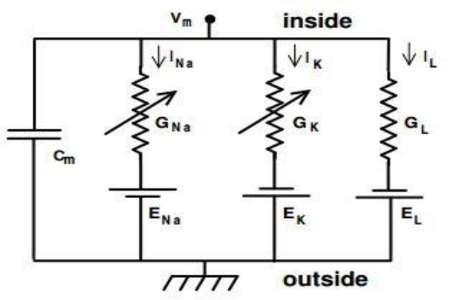
Fig 1: Electrical equivalent circuit proposed by Hodgkin and Huxley for a short segment of squid mgiant axon.

Alan Lloyd Hodgkin Andrew Huxley created this model based on their experiment on squid giant axon. This model describes how action potential is generated and propagated inside a neuron. It is a set of nonlinear differential equation that characterizes the electrical properties of a neuron. HH model describes about three types of ionic channels they are sodium channel, potassium channel and the leak channel. Channels can be thought to have gates that regulate the permeability of the pore to ions[1]. These gates can be controlled by membrane potential, producing voltage-gated channels. In this model the membrane current arises mainly through the conduction of sodium and potassium ions through voltage-dependent channels in the membrane. The contribution from other ionic currents is included as the leak current.

Open

Fig 2: Transition constants

The factors α and β are called the transition rate constants. α is the number of times per second that a gate which is in the shut state opens, while β is the number of times per second that a gate which is in the open state shuts. All the gates within a particular class have the same value of α and the same value of β at any instant in time, but gates which belong to different classes may have different values of α and β The great insight of Hodgkin and Huxley was to realize that gK depend upon four activation gates:

gK = gKn4 (1)

Whereas gNa depends upon three activation gates and one inactivation gate:

gNa = gNam3h. (2)

Here the variable m from Na+ denotes the probability of an activation gate being in the open state and h denotes the probability of an inactivation gate being in the open state. gK and gNa are the maximal conductance of the population of K+ and Na+ channels respectively. The factors n4 and m3h model the average proportions of channels in the open states for proportions of channels in the open state for potassium and sodium[1]. Thus for a cell the total current is given by the HH equation:

(3)

(4)

(5)

(6)

where I is the current per unit area, and and are rate constants for the i-th ion channel, which depend on voltage but not time. Is the maximal value of the conductance. n ,m and h are associated with potassium channel activation, sodium channel activation, and sodium channel inactivation, respectively.
Cable Theory

Cable theory shows how potentials spread in a dendritic tree. A typical neuron has thousands of synaptic inputs spread across its surfaces. Cable theory is concerned with how these inputs propagate to the soma or the axon initial segment, how these inputs interact with one another, and how the placement of an input on a dendritic tree affects its functional importance to the neuron. The theoretical results which Rall discussed in his paper indicates that dendrite can indeed make significant contributions to the receptive and integrative function of neurons[9]. Dendritic and axonal cables are typically narrow enough that variations of the potential in the radial or axial directions are negligible compared to longitudinal variations. Therefore, the membrane potential along a neuronal cable is expressed as a function of a single longitudinal spatial coordinate x and time, V(x, t). The dendritic or axonal cable can be visualized as a cylindrical membrane surrounding an intracellular fluid phase of constant cross-sectional area. R m and C m , which represent the specific resistance and capacitance respectively of one unit area of membrane[9] . Thus, if the radius, a, of the axon is known, then its circumference is 2πa, and its r m , and its c m values can be calculated as:

rm = Rm 2πa (7)

cm= Cm 2πa (8)

The greater the circumference of the axon the greater the area for charge to escape through its membrane and therefore the lower the membrane resistance and the more storage of charge. Similarly , the specific resistance , Rl of the axoplasm allows one to calculate the longitudinal intracellular resistance per unit length r by the equation:

Rl=Rl πa2 (9)

The cable equation is derived as:

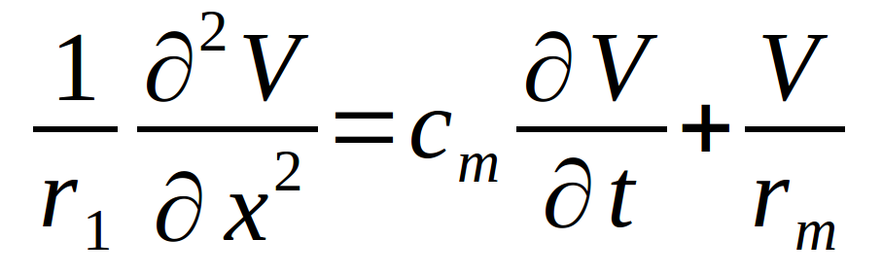
(10)

Multi Compartmental Model

In multi compartmental model of the neuron we include the dendrites or the axon as a series of discrete cylinders approximate them. This will help to simulate the propagation of current through the neuron. To approximate this we also use cable theory which computes the propagation of current through to dendrites or the axons. To simulate this model we first generate a connection matrix of the compartments to recreate the currents flowing in and out of the compartment. The current flowing out is added and the current coming in to one compartment from another is subtracted. The multi compartmental equation is a two half equation. In the first half the HH model values are calculate and in the second half the we calculate the contributions in and out of each compartment. Stimulus is added to a segment and the voltage trace is calculated.

Algorithm : Multi_compartmental

Given the functions am,an,ah,Bm,Bn,Bh. The parameters
ENa, EK,El and c,
the external current I and voltage trace vm output for
Hodgkin Huxley equation.

Input: (T,dt, S, elec)where where T is time,
dt is time step,S is number of compartment
elec is electrode position.

Initialize :
Cm NULL connection matrix represents the
contribution factor of each segment's current to every other
segment.

I[len_time] 0 stimulus matrix
Cm Connection_matrix()
stimulus matrix
For i 1 to (n) do
if i in range(5,10)
I[i] stimulus()
else
I[i] 0

For all i -- 1 in time T i+dt
begin:
Evaluate n compute_n()
Evaluate m compute_m()
Evaluate h compute_h()
compute hh
compute hh HH(m,n,h)
Calculate current contributions
dV (-hh) - dot_product(cm, vm) Ra
dv[elec] I[i]
vm vm + dt dV c
end
Plot graph(vm)

Integration Techniques

Euler Method
Euler method is a numerical procedure for solving ordinary differential equations with a given initial value. Suppose that we need to approximate the solution of the initial value problem
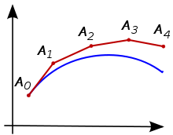

Fig: Illustration of Euler method. The unknown curve is in blue color and its polygonal vvv vapproximation is in red color.

y'(t)=f(t,y(t)),

y(to)=yo.

Here, y is an unknown function (scalar or vector) of time t which we would like to approximate. We are told that y',the rate at which y changes, is a function of t and of y itself. At the initial time to the corresponding y-value is yo. The function f and the data too are given pick a step-size h 0. Now, one step of the Euler method and set .Now, one step of the Euler method from tn to tn+1=tn+h is
yn+1=yn+hf(tn,yn)

Runge Kutta Method

In numerical analysis, the Runge–Kutta methods are an important family of implicit and explicit iterative methods, which are used in temporal discretization for the approximation of solutions of ordinary differential equations. These techniques were developed around 1900 by the German mathematicians C. Runge and M. W. Kutta.One member of the family of Runge–Kutta methods is often referred to as "RK4", "classical Runge–Kutta method" or simply as "the Runge–Kutta method[7]".

Let an initial value problem be specified as follows

y'=f(t,y) y(to)=yo.

Here, y is an unknown function (scalar or vector) of time t which we would like to approximate. We are told that y',the rate at which y changes, is a function of t and of y itself. At the initial time to the corresponding y-value is yo.The function f and the data too are given pick a step-size h 0 and define

Yn+1=Yn+(h 6) (k1+2k2+2k3+k4)
Yn+1=tn+h
for n = 0, 1, 2, 3, . . . , using

k1=f(tn,yn),
k2=f(tn+(h 2),yn+(h 2)k1)
k3=f(tn+(h 2),yn+(h 2)k2)
k4=f(tn+h,yn+hk3)

Here yn+1 is the RK4 approximation of y(tn+1), and the next value (yn+1) is determined by the present value and the weighted value of four increments.

Heun's Method

Euler’s method is used as the foundation for Heun’s method. In mathematics and computational science, Heun's method may refer to the improved or modified Euler's method or a similar two-stage Runge–Kutta method. It is named after Karl Heun and is a numerical procedure for solving ordinary differential equations (ODEs) with a given initial value. Both variants can be seen as extensions of the Euler method into two-stage second-order Runge–Kutta methods[11]. The procedure for calculating the numerical solution to the initial value problem via the improved Euler's method is:

y'(t)=f(t,y(t)) y(to)=yo.

by way of Heun's method, is to first calculate the intermediate value y'i+1 and then the final approximation yi+1

y'i+1=yi+h f(ti,yi)

yi+1=yi+(h 2)[f(ti,yi)+f(ti+1,y'i+1)

where h is the step size and ti+1=ti+h

Diagonally Implicit Runge Kutta Method

Here we deal with the numerical solution of initial value problems, for systems of ordinary differential equations (ODEs)[6], which can be written in the form:

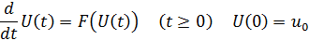

Where Δt represents a positive time step and n=1,2,3

Here kij are real parameters specifying the Runge kutta method and yi (1 i s) are

Intermediate approximation needed for computing values of u.

Results and Analysis

We implement Single Neuron Modeling using HH (No synapses) in CPU and record voltage response of single neuron, where Input current: square wave, 15 pA , for 150 ms simulation and the dt is 0.02.Euler method,RK4 method,Heun's method, DIRK4 method consume 3.628000 ms,22.877000 ms,10.459000 ms, 21.208000 ms for processing respectively.

CHANGE OF VOLTAGE WITH RESPECT TO TIMESTEP IN EACH INTEGRATION TECHNIQUE

Euler method
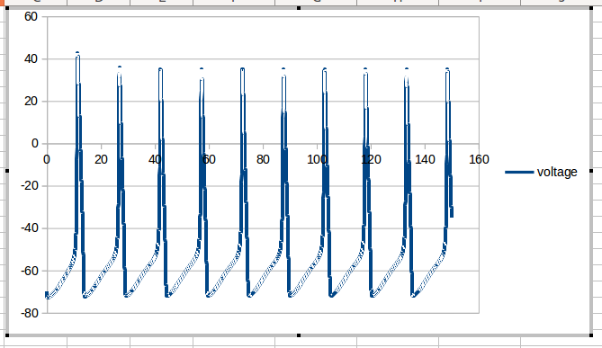

RK4 METHOD
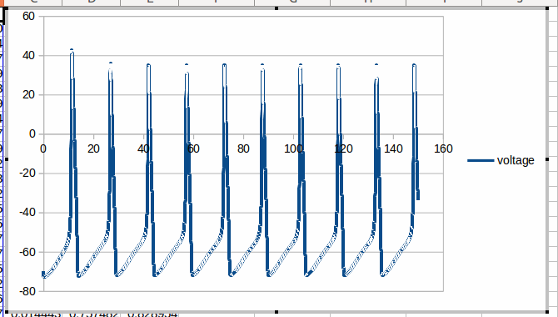

HEUN'S METHOD

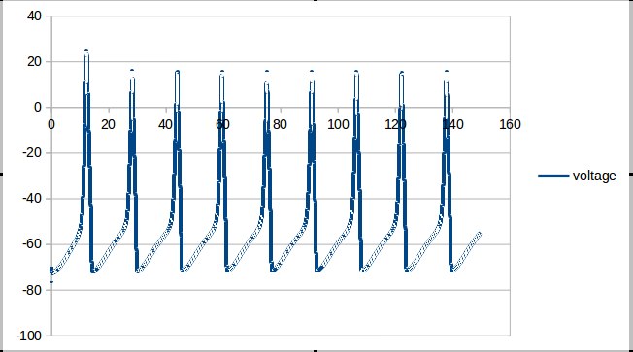

DIRK4 METHOD

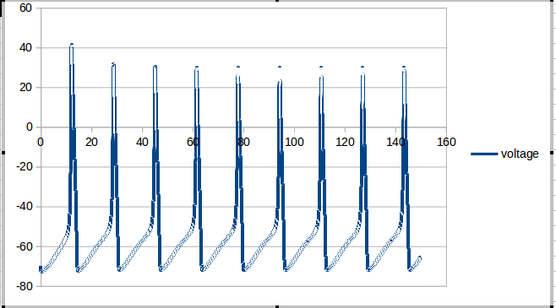

Conclusion Future Work

Euler is faster than other method but comparatively low accuracy it required to get an answer that is correct to time step should more less size that make more step for processing. This entails a high computational cost. For this reason, people usually employ alternative, higher-order methods such as Runge–Kutta methods or linear multistep methods, especially if a high accuracy is desired.Euler’s method is used as the foundation for Heun’s method. Heun’s method is much accurate than Euler and slower than Euler.Runge–Kutta4 gives more near approximation. But In Runge–Kutta4 method finding of next value is determined by the present value plus the weighted average of four increment (k1,k2,k3,k4). . It take more processing time and difficult in parallel processing .So DIRK is efficient for GPU simulation.
In future we plan to have a comparative study of integration technique in multi compartmental model. Large Scale Circuit Reconstruction of Spiking Neurons using CUDA. “Dynamic Parallelism” is to create a large scale GPU enhanced Neuronal Network simulation environment based on NVIDIA CUDA technology. We will be able to model and simulate the entire cerebellar circuit and will be able to test the behaviour of the cerebellar circuit on different inputs and on different conditions.

References

[1] Hodgkin, A. L. and Huxley, A. F. (1952).A quantitative description ofion currents and its applications to conduction and excitation in nerve membranes. J. Physiol. (Lond.).

[2] Mel, B.Â W. (1994).Information processing in dendritic trees.Neural Comput.

[3]Yamazaki, T., Igarashi, J. (2013). Realtime cerebellum: A large-scale spiking network model of the cerebellum that runs in realtime using a graphics processing unit. Neural Networks

[4]Fidjeland, A. K., Shanahan, M. P. (2010). Accelerated simulation of
spiking neural networks using GPUs. International Joint Conference onNeural Networks

[5]Izhikevich, E. M., Izhikevich, E. M. (2003). Simple model of spiking neurons. IEEE Transactions on Neural Networks

[6] L.Ferracina, M.N.Spijker(2007),Strong stability of singly-diagonally- implicit Runge Kutta methods,Math. Inst., Leiden Univ.

[7] SAli, Endre Mayers, David (2003), An Introduction to Numerical Analysis, Cambridge University Press.
[8] Butcher, John C. (2003), Numerical Methods for Ordinary Differential Equations, New York: John Wiley Sons.

[9] Rall, W. (1962a).Theory and physiological properties of dendrites.

[10] David Aaby,Dr. Muhammad Usman, Dr. Amit Singh,A (2009)Comparative Study of Numerical Methods for the Hodgkin-Huxley Model of Nerve Cell Action Potentials,University of Dayton Department of Mathematics.

[11] Ascher, Uri M. Petzold, Linda R. (1998), Computer Methods for Ordinary Differential Equations and Differential-Algebraic Equations, Philadelphia: Society for Industrial and Applied Mathematics.

